**Meher Kohli**

**Final Project Report**

**Overview and Summary of Project:**

My program reads a CSV file containing data about COVID cases and how hospitals were affected and then creates two graphs to showcase the active cases, deaths, and recoveries in the past few months. It also shows the corona patients in hospitals in general, the patients in ICU’s, and patients who need ventilators to provide an overall view of how corona is affecting hospitals as well.

The user will see a graph about the cases in general showing active cases, recoveries and deaths. The user has to close this window and a second graph will appear showing the hospital data information.

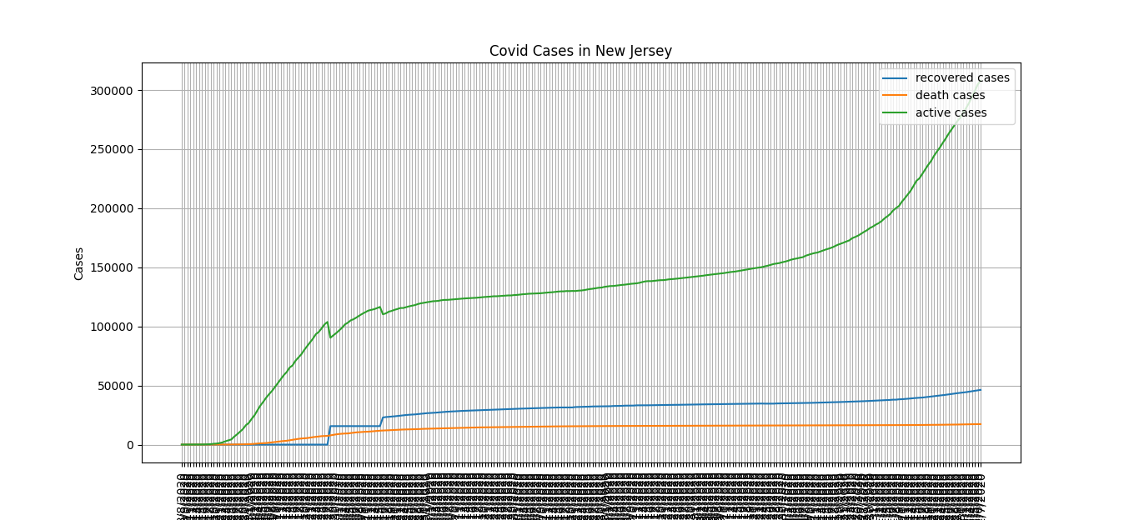

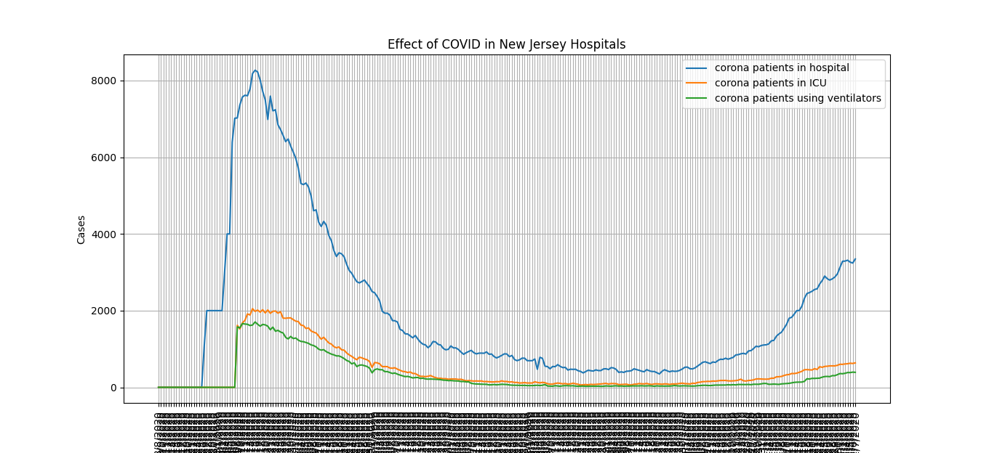

**Target Audience**:

The program targets the general public probably residents of New Jersey or anyone who is interested in seeing how the cases have been over the course of the past few months and how many active cases there are, recoveries, etc. It also targets hospitals workers, managers, and healthcare professionals who are interested in seeing how many ventilators are being used or how many ICU’s are being used for COVID patients to see which extent of their patients are suffering from COVID or not.

**Specific Programming Techniques Used:**

The program used lists as the rows I selected to graph were appended into lists and graphed. It also used functions. I created functions beforehand and called them while running the code to graph it easily. The functions helped create graphs and define the parameters of what to plot in each graph such as the title, ticks, and location of legend. I also used files as all this data was found in the CSV file which I had to call in my code so that it knew to get the information from there. I used strings when printing the statement informing the user of the next graph and how to access it. I also used floats to make sure only numbers were inputted. When saying which rows to append, I used the float() which would ensure no non-numerical characters.

The data was collected from the Department of Health in New Jersey and is added regularly by a bot who syncs the data as it is added to the csv found on GitHub. The information is based on reports and criteria by the state and is revised based on any information that is given.

**Challenge(s):**

One issue I had was a dataset one. In finding COVID data many datasets had one date assigned to too many locations which resulted in very weird graphs whose lines were wrong because of it. In this dataset, that issue was not present but there were some random gaps at first which needed to be fixed. To fix this, I had to put a 0 in each empty cell. Without doing so, the code would give an error claiming it could not convert a string to a float. After this was fixed, the code worked and all the rows I wanted were appended and the graphs were plotted.

Another issue I had was with the code. I thought it was not loading but I learned that PyCharm does not let you graph two graphs at once and that the entire code did in fact run, I just needed to close the first graph and then the second would load. To fix this issue, I added a print statement letting the user know they had to close the first graph after viewing to see the next one. This would ensure that the user would close it and see the next one because without closing, the code would not continue and show it.

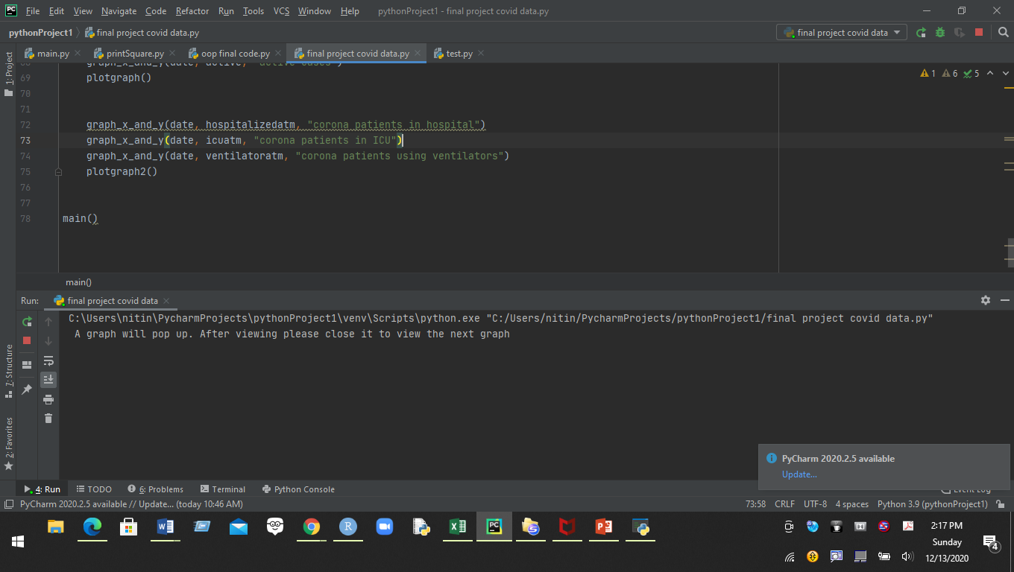

**Future Extensions:**

 I could extend this program to not only show the information regarding COVID cases in New Jersey, but in all 50 states and maybe around the world. Then, everyone could track how the cases have been in their respective areas but also worldwide as the new wave approaches and more areas go into lockdown. I think when more information comes about the vaccine, a way to extend this is map out the vaccine’s rate and COVID’s spread and make a model to predict how the cases would then look and what it means for everyone.